Java OCA Notes

Developed by sun microsystems in 1995.

Java is a highlevel , general purpose object orientend Programming language.

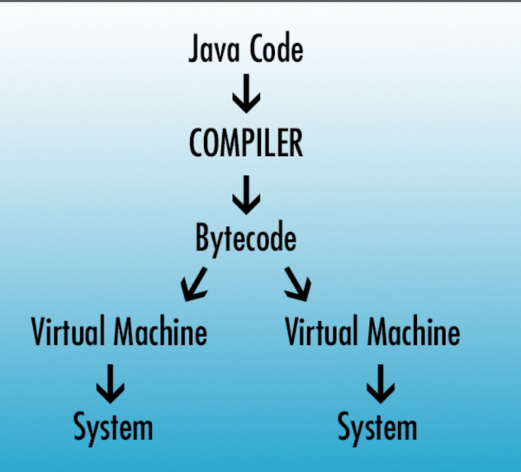

Write once , Run Anywhere.

When you install java , you also install a machine specific virtual machine which allows java programs to run it no matter where they have been compiled.

Where is Java Used ?

Applications , Web servers , Client-Side web applications , The Andriod OS , Games , Small Devices and everywhere.

Java JDK. - Java development Kit - this kit contains libraries and executables that allow us to do a bunch of awesome things.

JRE - Java run time environment.

JDK & JRE can exist harmonously because the JRE is a subset of the JDK. It only runs java applications but it cannot do any development.

JDK is installed on your system but its not visible via CMD ?.

If you don’t use an IDE you will be forced to write your java code on the commandline.

Need To download netbeans.

Working with Netbeans - go to new file and create new Java application and then give your project the name “Hello world”.

Source Packages and libraries is the most important file structures in the netbeans java app.

When creating first new project in netBeans , uncheck the create main so that it can give you bare app.

You will see src folder will be empty. So create new file called Helloworld in it. And netbeans will create HelloWorld.java.

.Java file is basically a text file that allows java code and comments only.

Comments are completely ignored by compiler

Comments are written with /\* \*/ IN Java.

Java code is read like english , top down and left to right.

Public static void main(string[] args) - this is the starting point for our Java program.

One of the benefits of working in an IDE It shows us which brackets are linked together.

System.out.printLn(“Hello world!”);

Java doesnt do a good job of reading spaces , so we need to use “;” to end a statement.

Functions in Java are just like files in the computer , they have a specific folder where they exist.

Building a project means that our code is compiled and turned into computer readable code.

When running the project Netbeans will ask you , which file you want to be the start of the program.

Hello world in Java is probably the scariest program you will write. From now on we need to take fewer leaps of faith.